SEBC – EXIT_TEST-CDH.5.11.2.4 Installation

1. Downloaded the parcels of CDH.5.11.2.4 and placed in local repo.

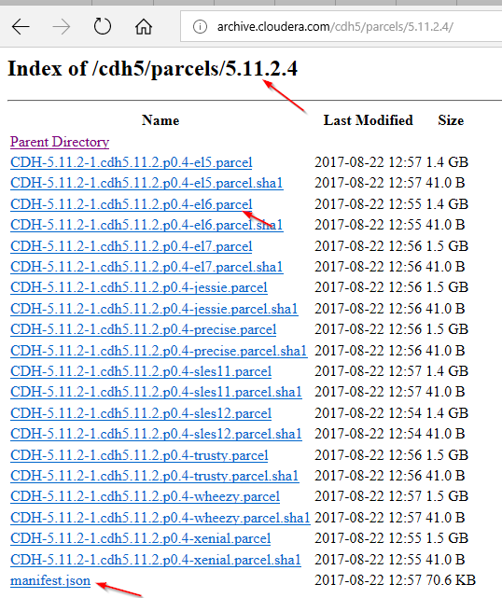

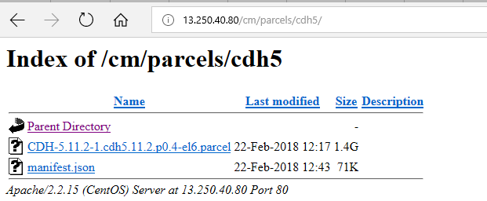

1. Configured the /etc/cloudera-scm-agent/config.ini in all nodes.

